**BK TOURIST WEBSITE REPORT**

**BY**

**AHMAD MUHAMMAD**

**1810204031**

**DEPARTMENT OF COMPUTER SCIENCE**

**FEDERAL UNIVERSITY BIRNIN KEBBI**

**Project Overview**

Bk tourist website is own by kebbi State tourist Association. The site is designed by Ahmad Muhammad, a student of computer science department, Federal University Birnin Kebbi.

The objective of this project is to design a static tourist website that provides valuable information to visitors about various tourist destinations, attractions, and activities at Kebbi State. The website aims to engage users with visually appealing design, user-friendly navigation, and informative content.

**Design and Layout**

The website follows a clean and modern design, incorporating a soothing color scheme inspired by the natural elements of the destinations. The layout is structured for easy navigation, with a consistent header and footer across all pages.

**Home Page**

The home page showcases a captivating hero image and a brief introduction to the website’s purpose. It features a prominent search bar, enticing users to explore destinations quickly.

**History**

The history page is organized by “Historical Sites.” Each historical site has a thumbnail image and a brief description, linking to individual site.

**Places to Visit**

The destinations page is organized into categories, such as “Foods,” “Forest,” and “Historical Sites.” Each category has a thumbnail image and a brief description, linking to individual destination pages.

**Individual Destination Pages**

Each destination page provides detailed information about the location, including a photo gallery, key attractions, local cuisine, accommodations, and travel tips. A map integration allows users to visualize the destination’s geography.

**Activities and Attractions**

This section highlights popular activities and attractions available across different destinations. Users can filter by their interests, such as “Adventure,” “Cultural,” or “Relaxation.”

**Content Strategy**

The content is curated to provide valuable and relevant information to potential travelers. It is written in a friendly and informative tone, ensuring users feel well-informed about their potential travel choices.

**Visuals and Media**

High-quality images are used throughout the website to showcase the beauty of each destination and the experiences visitors can expect. Videos are strategically placed to offer virtual tours and convey the atmosphere of the locations.

**User Experience (UX)**

The website prioritizes user experience by employing a responsive design, ensuring compatibility across various devices and screen sizes. Clear calls-to-action (CTAs) guide users towards exploring destinations, contacting for inquiries, and subscribing to newsletters.

**Technical Details**

The website is built using HTML, CSS, and JavaScript. The static nature of the website enhances loading speed and security.

**Conclusion**

The Bk tourist website successfully achieves its goal of providing users with an immersive experience of various tourist destinations. With its intuitive design, engaging content, and user-friendly features, it serves as a valuable resource for travelers seeking inspiration and information for their next adventure.

The site contain various pages which include:

Home page (index.html)

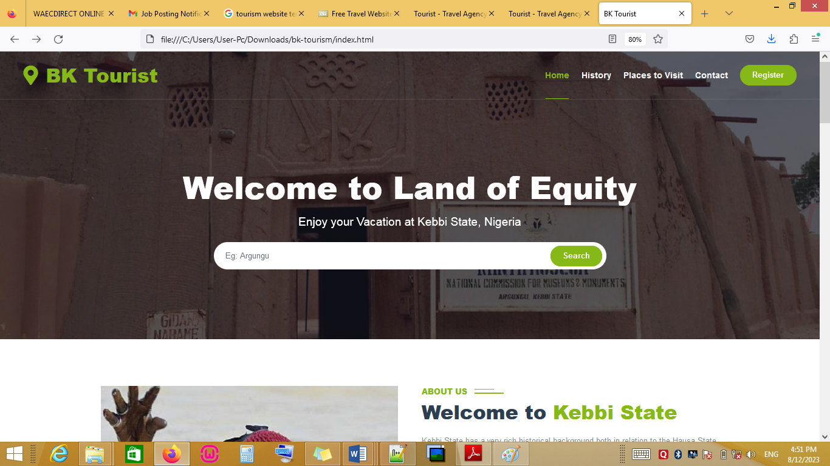

History Page (history.html)

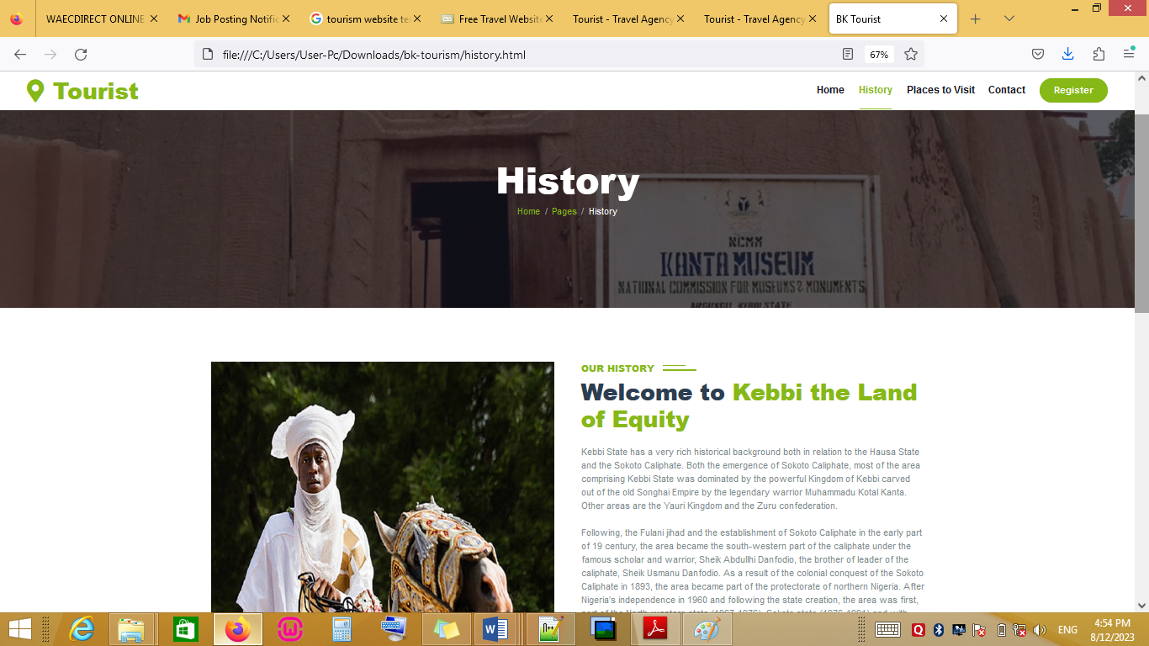

**Places to Visit(visit.php)**

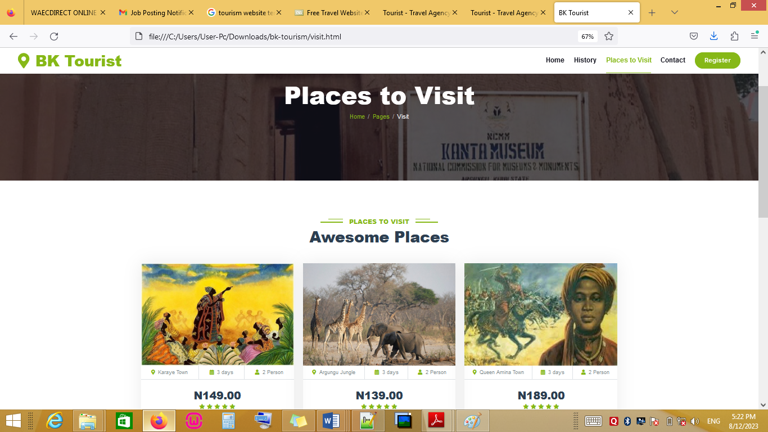

**Contact (contact us)**

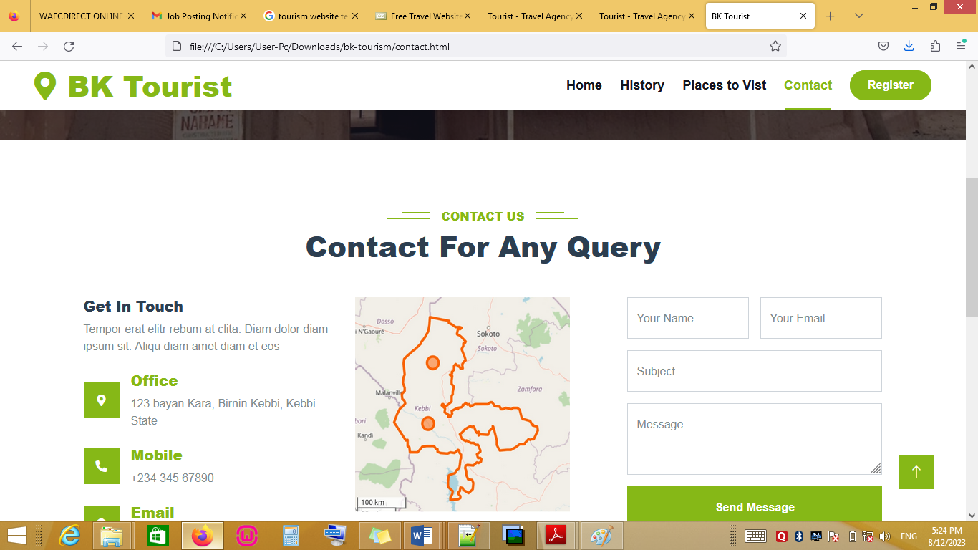

For more info. Visit: info@bktourist.com